**Practical-11**

**Aim: To study about Java script**

1.      Write a JavaScript to display “Welcome to UVPCE” in web page.

2.      Write a JavaScript to change background color of webpage using three buttons like red, green, blue.

3.      Write a JavaScript to find out the greatest number from three numbers.

4.      Write a JavaScript to find weather the entered number is even or odd.

5.      Write a JavaScript to generate Fibonacci series up to user choice.

6.      Write a JavaScript to find weather the entered number is prime or not.

7.      Write a HTML code design following form and display all textbox value in single message box.

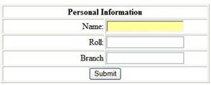

8.      Write a JavaScript to display system date in DD/MM/YYYY format.

9.      Write a JavaScript to display appropriate message according to system time.

10. Write a JavaScript to find pattern string according to starting and ending position of the given string and display it in Uppercase with font color is blue.

11. Write a HTML code design following form and display all value in single message box with validation:

